Errata - Rainbow Ephemeris 2007

1 / New Moon, 16 May 2007, Nouvelle Lune du 16 mai

To cut and paste on page 16: -> à découper et à coller en page 16

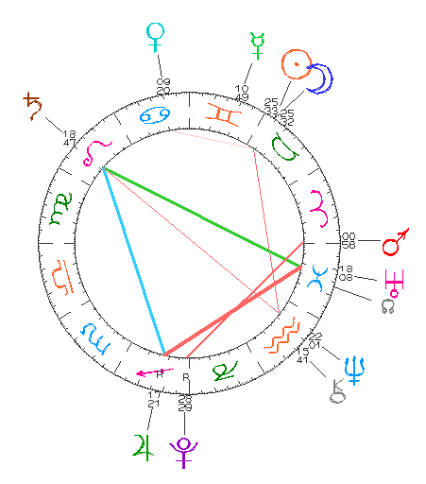

2 / Other mistakes: Autres corrections :

Page 5 : Full Moon Phases Table , May 2 (not May 3).
Page 11 : Declination graph (under the Declination Aspect Table)
Missing at the level of 8 Feb and 15° S : add a black occultation symbol
for Neptune occulted by the Sun.
Page 17 : Declination graph (under the Declination Aspect Table)
Missing at the level of 3 May and 15°30' N : add a black occultation symbol
for Mercury occulted by the Sun.
Page 31 : Declination graph (under the Declination Aspect Table)
Missing at the level of 23 Dec. and 23 °20' S : add a black occultation symbol
for Jupiter occulted by the Sun.
Page 34 : Other parans at 47°N : Neptune/ MC * Saturn / IC * Jupiter / DS.

With apologies,
Astrid

